AI ASSISTED CODING
LAB ASSIGNMENT – 2.2
NAME : N. SAI CHARAN
HALL.NO : 2403A52365
BATCH.NO : AI 13
ASSIGNMENT NO : 2.2

PROMPT 01 :
i need a pyhton code , unction that filters out all negative numbers from a given list
CODE :
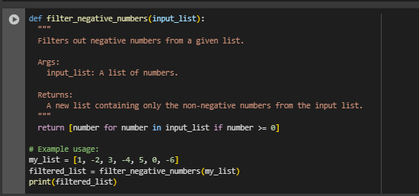
OUTPUT :
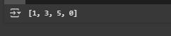
CODE EXPLANATION :
• Function Definition: The function filter_negative_numbers is defined to take a list of numbers as input.
• Docstring: The docstring explains the purpose, input, and output of the function clearly.
• List Comprehension: The function uses a list comprehension to iterate through each number in the input list.
• Condition Check: Inside the list comprehension, it includes only numbers that are greater than or equal to 0 (i.e., non-negative).
• Return Value: It returns a new list that contains only the non-negative numbers.
• Example Usage: A sample list my_list is passed to the function, and the filtered result is stored in filtered_list.
• Output: The print(filtered_list) statement displays the result: [1, 3, 5, 0].

PROMPT 02 :
I NEED A python code that reads a text file and counts the frequency of each word.
CODE :
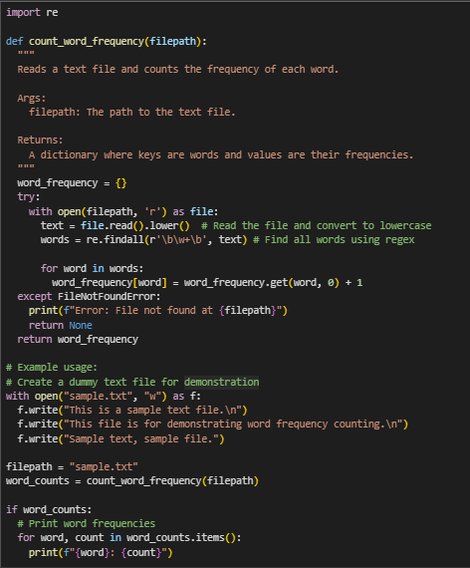

OUTPUT :
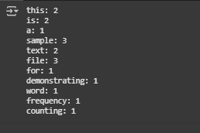

CODE EXPLANATION :
• Function Definition: The count_word_frequency function takes a file path as input and returns a dictionary of word frequencies.
• Docstring: Describes the function’s purpose, input (filepath), and output (a dictionary of word counts).
• Dictionary Initialization: word_frequency is initialized as an empty dictionary to store word counts.
• File Reading: The file is opened in read mode, and its content is read and converted to lowercase to ensure case-insensitive matching.
• Regex Word Extraction: re.findall(r'\b\w+\b', text) extracts all words using regular expressions, where \w+ matches word characters.
• Word Counting: A loop iterates through each word, using dict.get() to increment the count for each occurrence.
• Error Handling: A try-except block catches FileNotFoundError and prints a message if the file doesn’t exist.
• Return Value: The function returns the dictionary of word frequencies if successful.
• Example Usage:
- A sample file (sample.txt) is created with some text content.
- The function is called with this file’s path.
- If the result is valid, the script prints the frequency of each word.
PROMPT 03 :
I NEED A PYHTON CODE FOR a Python class called Book with attributes title, author, and a method summary() that prints the details

CODE :
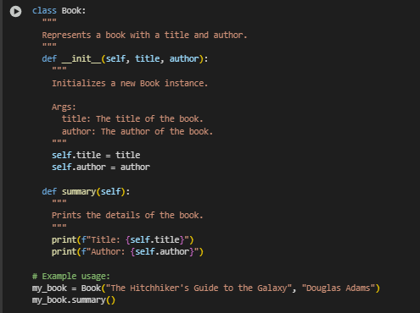

OUTPUT :
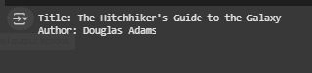

CODE EXPLANATION :
• Class Definition: The Book class is defined to represent a book with basic details like title and author.
• Docstring: Provides a brief description of what the class represents.
• Constructor (__init__):
- Takes title and author as parameters.
- Initializes instance variables self.title and self.author with the given values.
• summary() Method:
- A method that prints the book's title and author in a formatted way.
• Example Usage:
- A Book object is created with a title and author.
- The summary() method is called to display the book’s details.
PROMPT 04 :
GEMINI : i need a code that program that checks whether a number is an Armstrong number
CURSOR : modify the given code in simple terms
CODE & OUTPUT (GEMINI) :
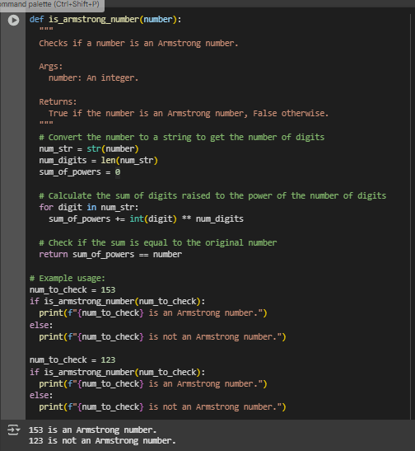

CODE & OUTPUT (CURSOR) :
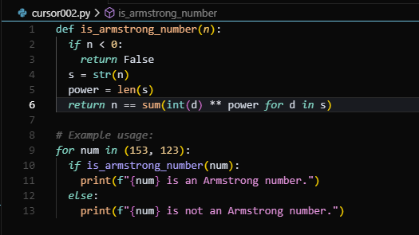
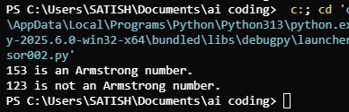
CODE EXPLANATION :
• Function Definition: The is_armstrong_number function checks whether a given integer is an Armstrong number.
• Docstring: Explains the purpose, input (number), and output (True or False) of the function.
• Digit Count: Converts the number to a string to easily count how many digits it has.
• Power Sum Calculation: Uses a loop to raise each digit to the power of the total number of digits and adds the result to sum_of_powers.
• Comparison: Compares sum_of_powers with the original number to determine if it is an Armstrong number.
• Return Value: Returns True if the condition is met; otherwise, returns False.
• Example Usage:
- Checks if 153 is an Armstrong number (which it is).
- Then checks 123, which is not an Armstrong number.
- Prints appropriate messages for both cases.

PROMPT 05 :
GEMINI : generate code for sorting a list of dictionaries by a specific key (e.g., age).
CURSOR : generate code for sorting a list of dictionaries by a specific key (e.g., age).
CODE & OUTPUT (GEMINI) :
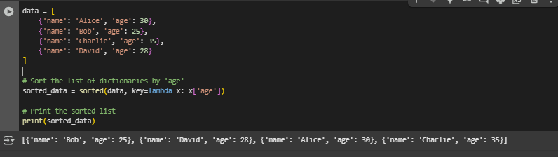
CODE & OUTPUT (CURSOR) :
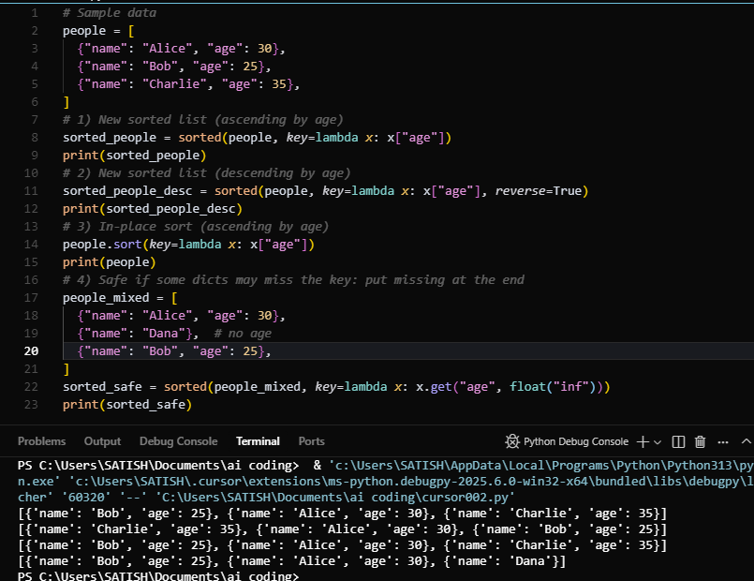

CODE EXPLANATION :
• Data Structure: A list named data is created, containing dictionaries. Each dictionary holds a person's name and age.
• Sorting:
- The built-in sorted() function is used to sort the list.
- A lambda function is passed as the key, which extracts the 'age' value from each dictionary for comparison.
• Sorted Result: The list is sorted in ascending order based on the 'age' field.
• Output: The sorted list is printed, showing people ordered from youngest to oldest.

